MODULE -1

1. **What is Software? What is Software Engineering?**

Ans. Software is a set of instructions, data or programs used to operate computers and execute specific tasks.

**Example** : MS Office, MS Word.

Software engineering deals with design, development, testing, and maintenance of software applications. It is used to bulid software solutions for end users.

**Example** : QA Engineer, Software Test Engineer, Cloud Engineer.

1. **Explain types of Software.**

Ans**. System Software:**

This type of software is designed to provide a platform for other software to run on. It includes operating systems like Windows, macOS, and Linux, as well as device drivers, firmware, and utility programs.

Operating systems manage computer hardware resources and provide services to applications. They control tasks such as memory management, process scheduling, and file system management.

**Application Software:**

Application software serves specific purposes for end-users. It includes programs like word processors, spreadsheets, web browsers, and multimedia players.

This type of software is often designed to perform tasks such as creating documents, managing finances, browsing the internet, or editing photos and videos.

**Programming Software:**

Programming software provides tools for developers to create, debug, and maintain software applications. Examples include integrated development environments (IDEs), compilers, debuggers, and text editors.

These tools help programmers write code more efficiently, test their programs, and manage software projects.

**Middleware:**

Middleware is software that sits between an operating system and the applications running on it. It enables communication and data management between different software applications or distributed systems.

Examples include database management systems (DBMS), application servers, and messaging middleware.

**Utility Software:**

Utility software performs tasks related to system maintenance, security, and optimization. Examples include antivirus programs, disk cleanup utilities, backup software, and file compression tools.

These programs help users manage and protect their computers, improve performance, and recover lost data.

**Embedded Software:**

Embedded software is specialized software that is part of a larger system or device. It is often stored in read-only memory (ROM) and controls the operation of hardware devices.

Examples include firmware in devices like smartphones, digital cameras, and home appliances, as well as software in automotive systems, industrial equipment, and medical devices.

**Enterprise Software:**

Enterprise software is designed for use by organizations to support their business processes and operations. It includes applications for enterprise resource planning (ERP), customer relationship management (CRM), supply chain management (SCM), and human resource management (HRM).

These systems help companies streamline their operations, improve efficiency, and make informed decisions based on data analysis.

Each type of software plays a critical role in the functioning of computers and electronic devices, serving various needs of users and organizations.

1. **What is SDLC? Explain each phase of SDLC.**

Ans. Software Development Life Cycle (SDLC) is a process used by the software industry to design, develop and test high quality softwares. The SDLC aims to produce a high-quality software that meets or exceeds customer expectations, reaches completion within times and cost estimates.

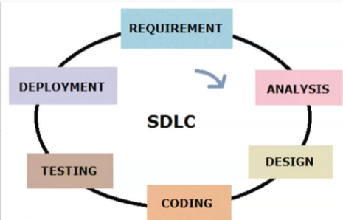

**Phases Of SDLC :**

1. Planning and Requirement Analysis :

* Planning for the quality assurance requirements and identification of the risks associated with the project is also done in the planning stage. The outcome of the technical feasibility study is to define the various technical approaches that can be followed to implement the project successfully with minimum risks.
* Requirement analysis is the most important and fundamental stage in SDLC. It is performed by the senior members of the team with inputs from the customer, the sales department, market surveys and domain experts in the industry. This information is then used to plan the basic project approach and to conduct product feasibility study in the economical, operational and technical areas.

1. Defining Requirements :

* Once the requirement analysis is done the next step is to clearly define and document the product requirements and get them approved from the customer or the market analysts. This is done through an SRS (Software Requirement Specification) document which consists of all the product requirements to be designed and developed during the project life cycle.

1. Designing the Product Architecture :

* SRS is the reference for product architects to come out with the best architecture for the product to be developed. Based on the requirements specified in SRS, usually more than one design approach for the product architecture is proposed and documented in a DDS - Design Document Specification.
* This DDS is reviewed by all the important stakeholders and based on various parameters as risk assessment, product robustness, design modularity, budget and time constraints, the best design approach is selected for the product.
* A design approach clearly defines all the architectural modules of the product along with its communication and data flow representation with the external and third party modules (if any). The internal design of all the modules of the proposed architecture should be clearly defined with the minutest of the details in DDS.

1. Building or Developing the Product :

* In this stage of SDLC the actual development starts and the product is built. The programming code is generated as per DDS during this stage. If the design is performed in a detailed and organized manner, code generation can be accomplished without much hassle. -- Developers must follow the coding guidelines defined by their organization and programming tools like compilers, interpreters, debuggers, etc. are used to generate the code. Different high level programming languages such as C, C++, Pascal, Java and PHP are used for coding. The programming language is chosen with respect to the type of software being developed.

1. Testing the Product :

* This stage is usually a subset of all the stages as in the modern SDLC models, the testing activities are mostly involved in all the stages of SDLC. However, this stage refers to the testing only stage of the product where product defects are reported, tracked, fixed and retested, until the product reaches the quality standards defined in the SRS.

1. Deployment :

* Once the product is tested and ready to be deployed it is released formally in the appropriate market. Sometimes product deployment happens in stages as per the business strategy of that organization. The product may first be released in a limited segment and tested in the real business environment (UAT- User acceptance testing).
* Then based on the feedback, the product may be released as it is or with suggested enhancements in the targeting market segment. After the product is released in the market, its maintenance is done for the existing customer base.

1. **What is Flowchart? Create a flowchart to make addition of two numbers.**

Ans. Flowchart is graphical representation of algorithm.

Algorithm for Addition of two Numbers :-

1. Start
2. Declare n1,n2,ans
3. Read n1,n2
4. ans->n1+n2
5. display ans
6. Stop

Flowchart :-

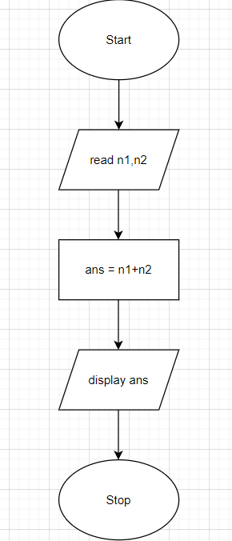

1. **What is DFD? Create a DFD diagram on Flipkart**

Ans. **DFD** is the abbreviation for **Data Flow Diagram**. The flow of data of a system or a process is represented by DFD. It also gives insight into the inputs and outputs of each entity and the process itself.

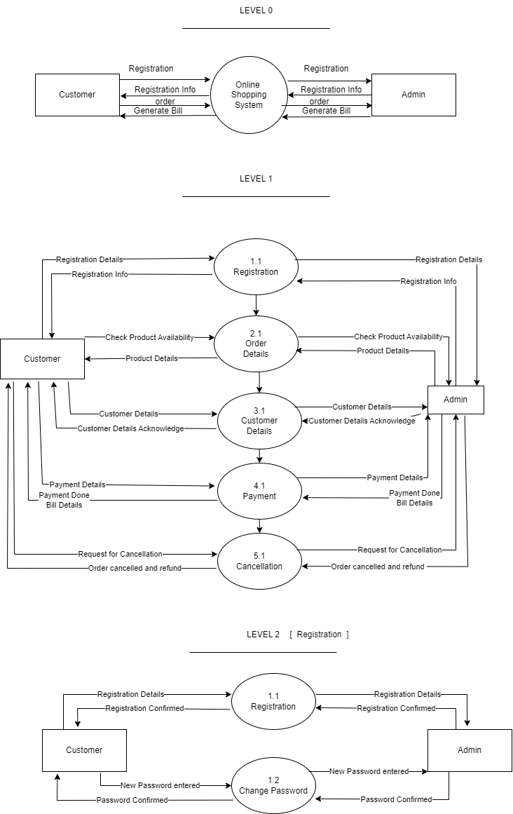

1. **What is Use case Diagram? Create a use-case on bill payment on paytm.**

Ans.A Use Case Diagram is a vital tool in system design, it provides a visual representation of how users interact with a system. It serves as a blueprint for understanding the functional requirements of a system from a user’s perspective, aiding in the communication between stakeholders and guiding the development process.

